Name _________________________
Date __________________________
Warm up TV-Studio

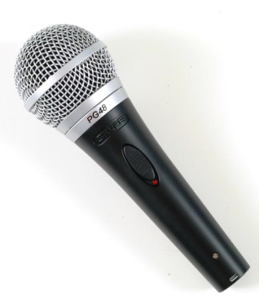
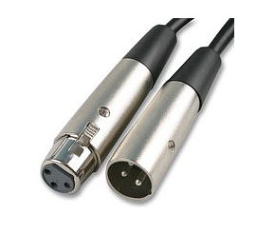
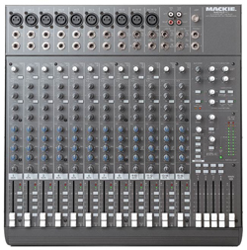
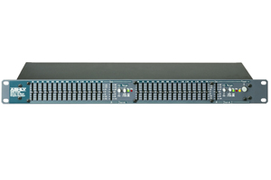
Please show the two main ways a microphone, a equalizer, and a sound board can be connected together. Copy and Paste items as needed

